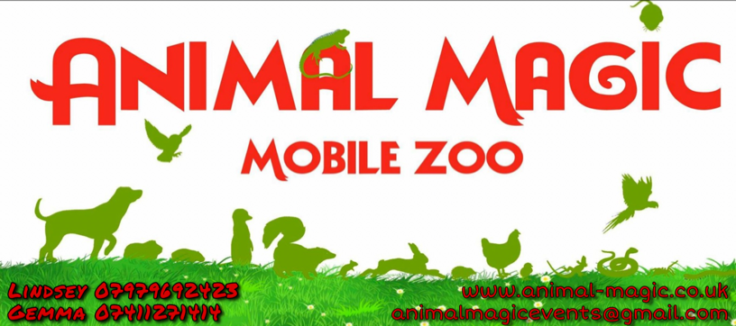

Method Statement

We Will:

- Carefully transport animals and equipment, stopping for regular breaks
- Be punctual, arriving in time to set up suitably for the event
- Co-ordinate with the event organiser
- Check area selected is suitable for animals
- Set up enclosures and equipment
- Install feeding and watering equipment
- Checks – Security of pens and health and safety (i.e. signs and hand washing)
- Ensure animals are ready to leave the vehicle safely
- Move animals into enclosures/pens
- The handlers will then proceed with displaying the animals
- Any animals the show signs of aggression of tiredness will be immediately removed
- At the end of the event all pens and animals are removed safety and loaded
- The area which has been used will be cleared of any excess waste or debris

All events differ, the above is a guide. We are happy to adapt depending upon customer requirements. It is important that the senior events organiser greets our team on arrival.
A site visit can be arranged prior to the event subject to an additional cost.

